Vertical Gallery Proposal – Degree Show 2020
Name: Ameerah Dawood
Course: Textiles in Practice

Concept:
“The reason we feel so at peace around nature is because we are a part of it”
One way I consistently calm myself, is by listening to sounds that derive from nature, such as rain, birds, ocean waves etc. I therefore wanted to create a body of work that responds to these calming sounds in a painterly abstract way and in doing so evoke a sense of calm and serenity. My work aims to be a visual interpretation of these sounds to evoke a meditative response in the viewer. A moment in which the viewer can stop and immerse themselves in the work and the sound. This is something important to me as I feel within urban living we often forget about our natural heritage and the solace that we can find within it.
Quarantine allowed me to understand just how important my concept was in terms of natures impact on mental health. With the current impact to our daily routines, we have resorted to nature to centre ourselves and ease our way into a new normal. My daily walks have become the focus of my drawing development and I am able to pay much more attention to my natural surroundings. This meant that my project had much more depth than it originally would have.
Proposal:
My proposal is to form a large-scale series of digital fabric prints in which the marks flow through each segment, but even though they are comprised of separate elements that focus on the same place at varying points of the day, they create one large visual soundscape.
Suggestion:
My proposal is to create a large-scale work which is a representation of a location, studied at various times of the day to create a visual soundscape. The displayed work will be made up of a series of digital prints, each one connected by the marks which flow through them.
The idea is to represent how the different components of an environment work in harmony to create a whole peaceful atmosphere in which we can find some calm. The scale commands attention and gives the opportunity for a viewer to immerse in a meditative moment, whether they focus on detail or view as a bigger picture.
I also would also have audio equipment and headphones that play my audio research I conducted, for the viewer to become fully immersed in the soundscape, by listening and viewing the piece in correlation. The chosen location of Benzie Groundfloor allows this piece to represent that even in a hectic environment one can find solace in natural elements.
SORRY I DELETED THIS PARAGRAPH BY ACCIDENT. CAN YOU COPY AND PASTE IT BACK IN?

I have provided links to some of the clips I have taken and uploaded to YouTube.
https://www.youtube.com/watch?v=ufoWEfORors
https://ww.youtube.com/watch?v=ykacHrvJlz8
https://www.youtube.com/watch?v=IsPSFdWIF8U

Design Concept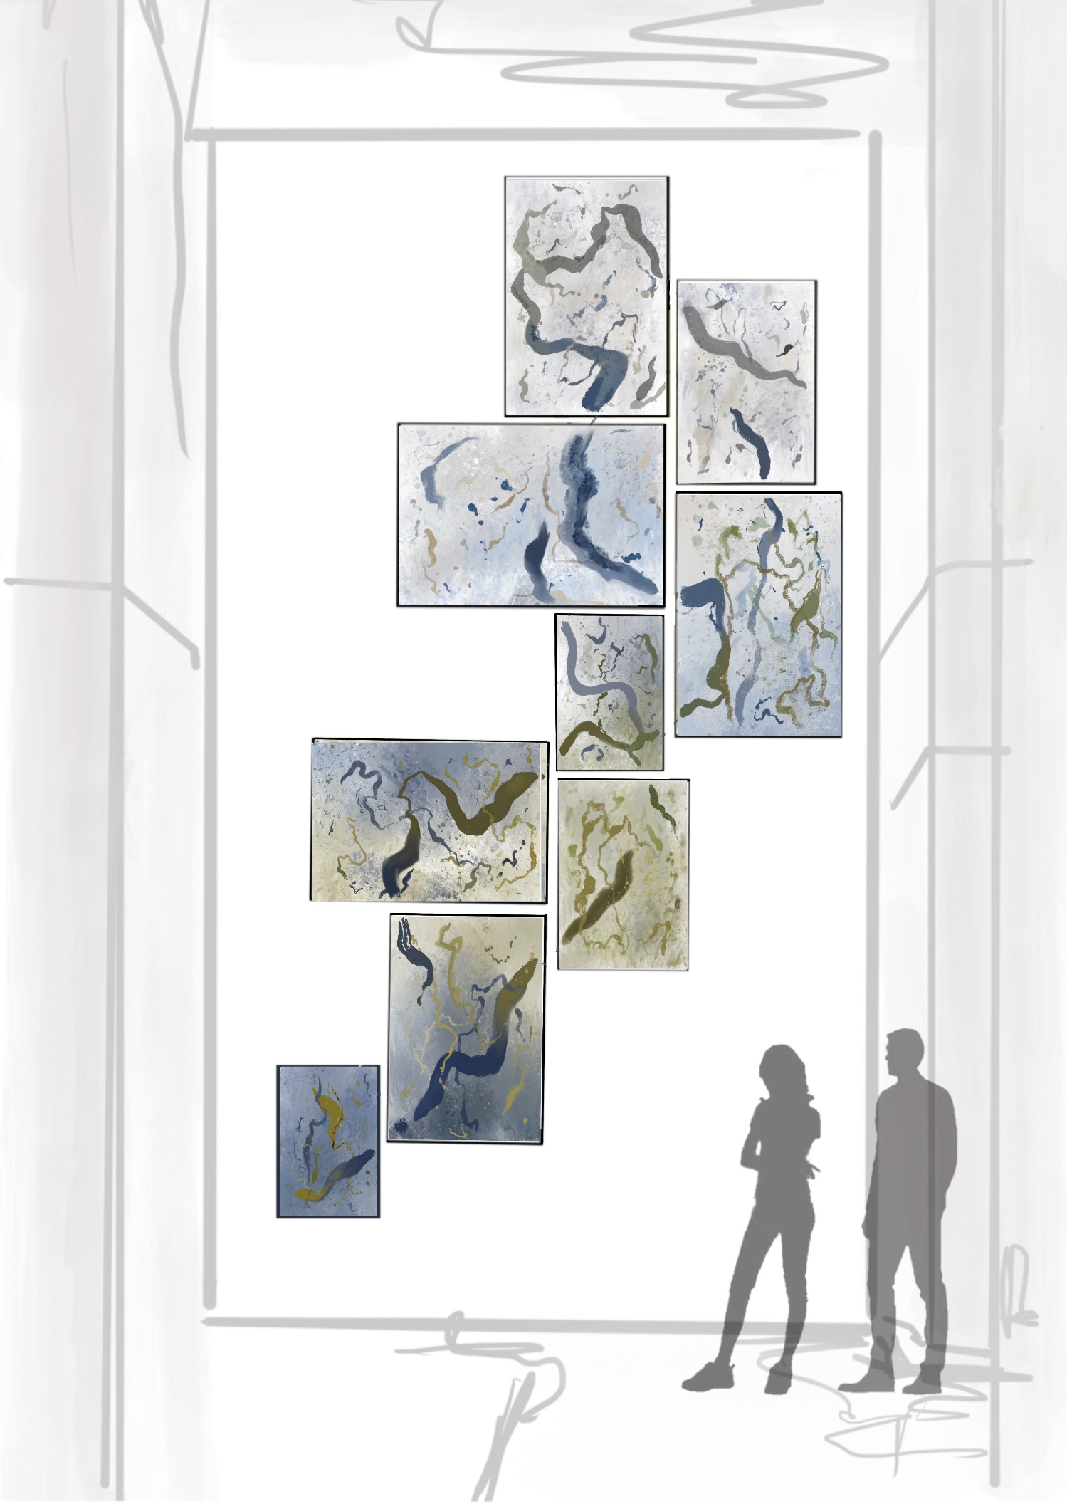
Figure 1 Visualisation of Fabric Print composition. Representing how the natural sounds of a single environment over a period of time is still harmonious together.

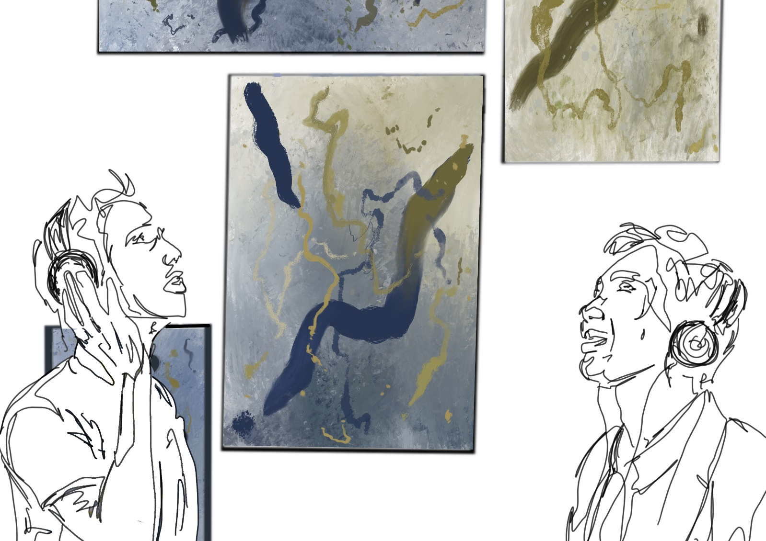
Figure 2 Visualisation of viewers engaging in with the piece by listening to audio
Method and Materials:

-Prints will be designed to scale via Procreate and Photoshop at 300dpi to ensure quality.
-Each piece will be printed on the Fabric Digital Printers via TIFF file onto Cotton Canvas. Fabric Tests will need to be conducted in order to test colour translation onto the fabric therefore I would like to apply for a small testing fee of £25 in order to do so. (See Page 5 for further costing details)
-The width of the printer is 1.45M and the length is continuous therefore pieces can have their orientation changed to fit the printer.
- Printing onto fabric also allows for textural details to be added if it is possible
-Additional timing and costing may have to be factored in such as framing if deemed necessary.

Scale
- I have calculated an approximate scale of each section in relation to the size of the wall. This may be subject to minor changes.

Costing

- The width of the fabric printer is 147cm
- A meter length of print that uses the full width of the fabric comes to £23.21
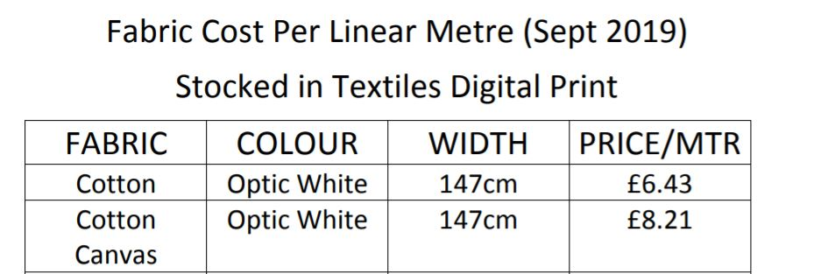

Figure 3 Fabric Costings: Provided by Print Room Technicians

Direction of Fabric Printer
7.9 Meters in length

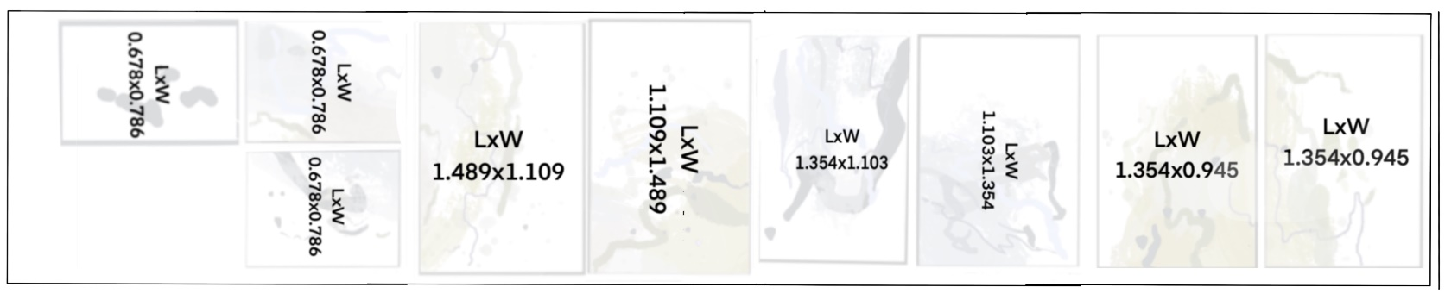
Width 147cm
Figure 4 Visualisation Estimation: Sections orientated to fit the fabric printer. Some may need resizing.

- With the aid of the print room technicians I have calculated an estimated cost based on the meters of print needed and full width of fabric.
- Estimated Cost: £23.21 x 7.9 = £183.34

Mounting

- Due to the scale of the piece, a qualified technician who is trained in using equipment to reach those heights is required to aid me in assembly.
- Each piece will be mounted so that its linear aspect aligns with its cohesive partner, therefore possibly magnets or strong Velcro tabs that are easily moveable will be needed to mount each piece.
- Headphones and audio equipment will be mounted at eye level.

